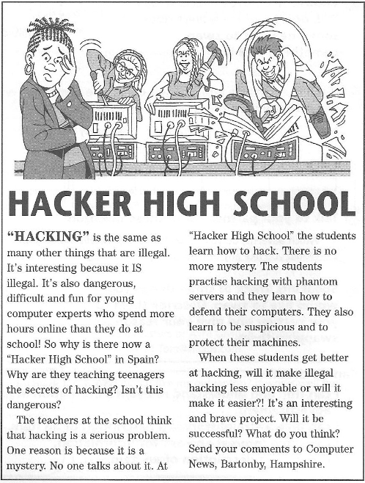
- Read next text and Answer questions below.

- What do you think the article is going to be about?
- A secret school
- A new type of school

- What do you think happens at this school, according to the reading?

- Read the text and answer the questions below. For each question underline the correct letter A, B or C.

- Young people
- Spend a long time ate school.
- Spend an hour a day on computers
- Spend a long time each day on computers.

- At “Hacker High School”
- They teach the children
- Everything is a secret.
- Teenagers learn useful thing.

- The writer of the article
- Thinks “Hacker High School” is a bad thing.
- Is not sure if it is a good or bad thing.
- Thinks “Hacker High School” is a good thing.

- What do you think these words from the article mean? Choose A or B

- Illegal | a) against the law | b) very expensive
- Phantom | a) not important | b) not real
- Defend | a) build | b) stop something hurting you
- Suspicious | a) accept everything | b) think about possible problems

- Match these computer words with their meaning?

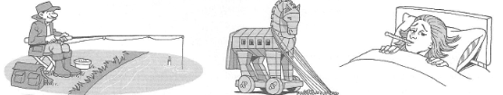

- Virus a) These e-mails ask for personal information
- Firewall b) This is something that looks Ok but it’s really dangerous
- Key logging c) These are adverts and e-mails you do not want
- Phishing d) This protects your computer.
- Spyware e) This can kill your data.
- Spam f) This can fallow your keys to get personal information.
- Trojan g) This secretly watches which sites you visit.

- Make 5 questions which include next options, according to the reading or to the work at Ciberschool.
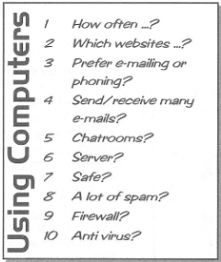
- How often do we use chat rooms?

