
Hello, my friends

Pets are beautiful, but they’re also quite demanding.

You should think twice before having a pet in order to choose the best option. You also have to be very conscious about the things they need, such as time, food, place……..

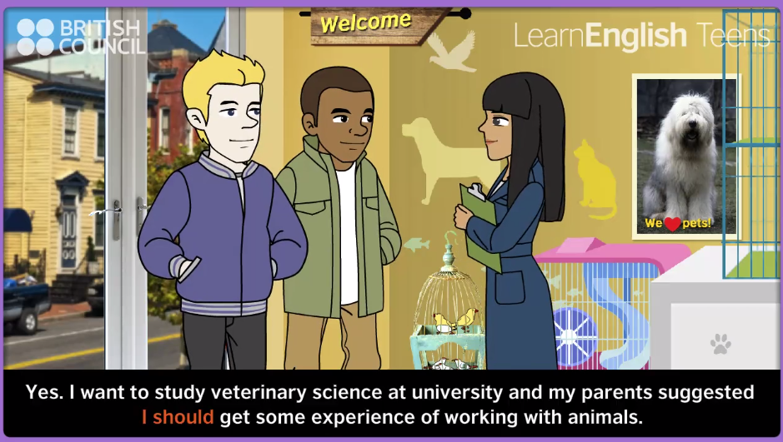

Watch this video, and identify how to use some modal verbs:

http://learnenglishteens.britishcouncil.org/grammar-vocabulary/grammar-videos/have-must-and-should-obligation-and-advice

ACTIVITY. From the last video, identify the characteristics of some animals, and what people must do when they have some pets:

 | Pet | Characteristics / needs | Recommendation
1 | Dogs (Dalmatians) | They are big, and need a garden. | People have to take them out for a walk at least once a day
2
3
4
5
6
7
8
9
10 | Why did he decide buying a fish?
11 | Do you like pets? |  | Yes – why?  No – why?
12 | Are there pets in your house?
13 | What pet do you suggest Oliver buying? Why?
14 | Concerning the dialogue between mother and daughter, what should mother do?

When buying a pet we need to plan many things:
- Food
- Cares
- Time
- Place
- . . .

I’m going to buy a dog, because I like pets. Dogs are lovely and loyal.

PRACTICE: take this quiz and identify how well you use the future GOING TO:
https://learnenglishkids.britishcouncil.org/en/grammar-games/going-plans
(Ask your teacher to explain you the wrong answers)

ACTIVITY. Watch the next video about future plans, and write some sentences about Henry:
https://www.youtube.com/watch?v=G7YVSmpDFZQ
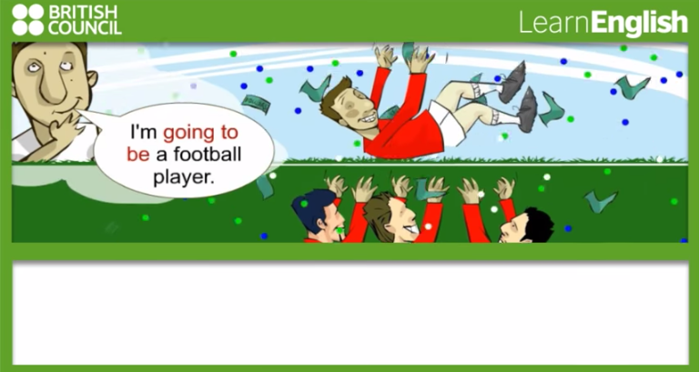
1 | Henry is going to be a football player.
2
3
4
5
6
7

PRACTICE. Go to this video and watch how to describe future plans:
https://www.youtube.com/watch?v=vZsFu3nyUiY

